2. (25p) Answer the question on an electronic document. The Radar equation accounts for the relation between several terms involved with the range and the radar performance (usually stated by the false alarm and probability of detection). Once this relation is set by the figures reproduced during session 2, outline several ways of using an extra peak power of 3 dB if you do not need to change the operating ranges. Support your responses with several figures (or a single figure with several curves). Use the initial values as listed in 2.2 of session 2 lab report.

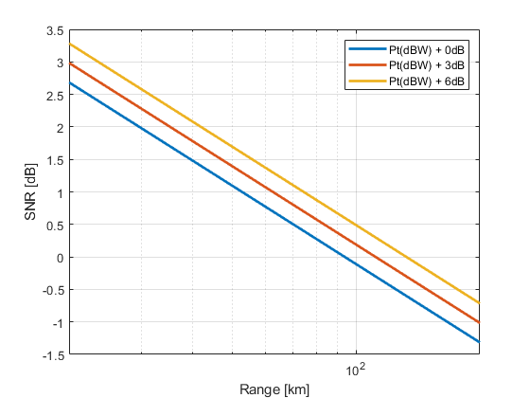

Figure 1. Peak power to range

With peak power increase of +3db, the range of the radar range increases by a lot. As visible in the figure 1. But if we don’t want to increase the range. We can go to the formula and modify parameters.

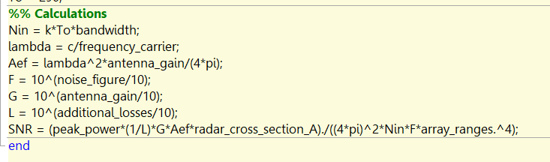

For example, as we can see above in the formula. If we want to maintain the range which equals to same SNR. We can play with other parameters.

We can reduce the antenna size, radar cross section of the target can be smaller, losses can also be higher now, the noise factor of the antenna can also be worsen compared to original if we have extra +3dB increased peak power.

The losses can be twice as high

The radar cross_section_A can be twice as small

The effective area of the antenna can be twice as small,

The gain on the antenna can be twice as small, The F or noise factor can be increase times 2.